- Bluebook Page68 August 2019 variant five examination:

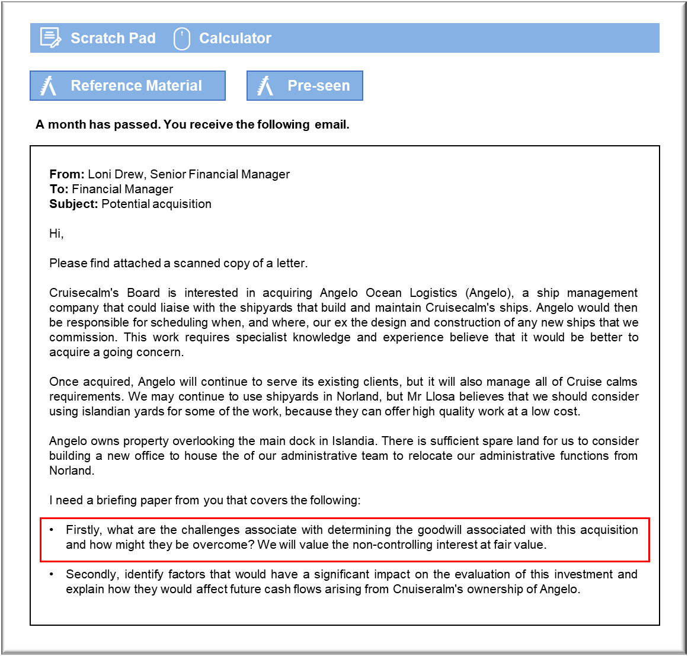

MANAGEMENT CASE STUDY AUGUST 2019 EXAM ANSWERS

Variant5 Task2
These answers have been provided by CIMA for information purposes only. The answers created are indicative of a response that could be given by a good candidate. They are not to be considered exhaustive, and other appropriate relevant responses would receive credit.

CIMA will not accept challenges to these answers on the basis of academic judgement.

Requirement 1: Goodwill on acquisition
The first challenge is in determining the fair value of the company’s separable net assets as at the date of acquisition. Angelo appears to hold a large amount of land, which may prove difficult to value because it occupies a key location overlooking the docks. The size and location of the land could mean that there are no observable comparisons that might be used to determine its fair value.
The second challenge is the fact that the owner is retaining 10% of the equity, which is to be
valued at its fair value. That could be a problem because the company is unquoted, otherwise Mr Llosa would not have a 100% stake. Mr Llosa could have insisted on retaining a small percentage of the company for personal reasons that do not reflect the fair value of the holding.
It may not necessarily be logical to argue that the 10% holding can be valued on a proportionate basis to Cruisecalm’s payment for the remaining 90%. Mr Llosa’s stake in the company may be too small to exert any meaningful influence, which could reduce its fair value.
The first challenge might be overcome by investigating whether any other land has been sold in the area of the Islandia docks in the past few years. If so, it might be possible to establish a rough market value for the land that we will acquire as part of the deal. The alternative would be to identify alternative sites for the office building that we plan to erect in that area, with a view to establishing how much a similar site would cost.
The second challenge might be overcome if there is a quoted company in that business in
Islandia. Islandia appears to be a maritime country and, so, there could be other businesses that offer the same service. If we were able to identify a quoted company, then we could use a model such as the dividend growth model to identify factors that could be input into a calculation of a fair value for Angelo’s shares. If we cannot identify a similar company in Islandia then, hopefully, we will be able to find one in another country that has a similar economy and business culture.

Requirement 2: Net present value
The most significant factor will be Angelo’s ability to ensure a sound liaison with shipyards that have been tasked to build and repair Cruisecalm’s ships. This may be a matter of concern because Angelo is located in Islandia and Cruisecalm intends to continue to use shipyards in Norland, at least initially. Any issues with the quality or speed of completion could easily outweigh any savings that might be offered by switching to Angelo. It should be borne in mind that the liaison will have to be maintained at a distance because of location.
The fact that Angelo will be acquired as a going concern means that it will have ongoing
commitments to its existing clients. Those may interfere with Angelo’s ability to absorb the
additional work that will have to be undertaken on behalf of Cruisecalm. If Angelo gives
Cruisecalm priority, then it could be faced with penalties in respect of delayed work for third
parties, which, again, could outweigh any savings in terms of operating costs.
Angelo’s contacts could offer significant savings in the medium to long term, if it can recommend yards that can provide high quality work at a saving. If such potential savings can be realised, then Angelo’s NPV could be far greater than the operational cost savings that had been anticipated. The risks associated with this change could require the savings to be discounted at a higher rate of return to allow for the problems that might occur.
The availability of building land at Angelo’s premises could offer further cost savings that would translate into a higher cash inflow. The land could be used to extend the office space at Angelo to accommodate the other administrative staff who will be taken on by Cruisecalm. That would make it even cheaper to relocate those functions to Islandia and might improve efficiency because of the whole administrative base being in a single location.

